1. **Definition of AI and Augmented Intelligence:**
   * AI is defined as anything that enhances machines' abilities to act intelligently.
   * The concept of AI here is seen as "augmented intelligence," aiming to extend human capabilities rather than replacing human expertise entirely.
   * The goal is to enable machines to perform tasks that neither humans nor machines could accomplish alone.
2. **Impact of Technological Advancements:**
   * Technological advancements, such as the internet, distributed computing, IoT (Internet of Things), and social networking, have contributed to an explosion of data availability, often unstructured.
   * Augmented Intelligence aims to provide subject matter experts with the necessary information and evidence promptly, facilitating informed decision-making.
3. **Understanding Intelligence:**
   * Human innate(inborn) intelligence is seen as the guiding force behind all bodily activities and even natural phenomena like the growth of an oak tree from a seed or the development of an elephant from a single-celled organism.
4. **AI Learning Process:**
   * Machines lack innate intelligence; they learn from the information provided to them.
   * AI learning involves examining examples and creating machine learning models based on input and desired outputs.
   * Different learning methods like Supervised Learning, Unsupervised Learning, and Reinforcement Learning are used to teach AI models.
5. **Types of AI based on Capability:**

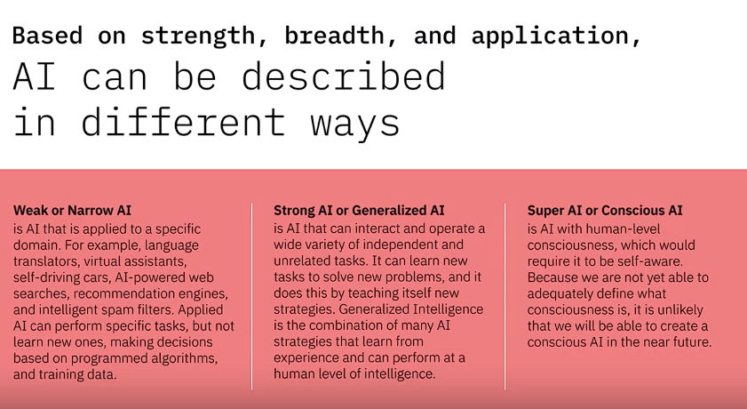

* + Weak or Narrow AI is specialized in a particular domain and can perform specific tasks based on programmed algorithms and training data.
  + Strong or Generalized AI is more versatile, capable of learning new tasks and solving unrelated problems, akin to human problem-solving abilities.
  + Super AI or Conscious AI is a theoretical form of AI that would possess human-level consciousness and self-awareness, which remains a distant possibility due to the complexity of defining consciousness.

1. **Interdisciplinary Nature of AI:**
   * AI draws from various fields of study such as computer science, electrical engineering, mathematics, statistics, psychology, linguistics, and philosophy.
   * Each discipline contributes to different aspects of AI development, from its technical implementation to understanding intelligence, ethics, and potential limitations.
2. **Real-world Impact and Application of AI:**
   * AI has already shown its usefulness across various domains, impacting daily decisions and significantly affecting society.

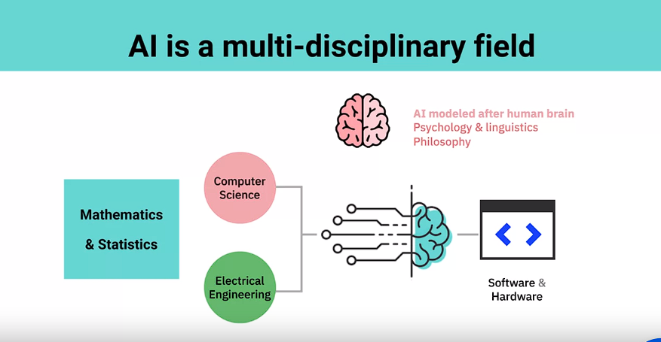

1. **Definition of Artificial Intelligence (AI):**
   * The speaker acknowledges the multitude of definitions surrounding AI.
   * AI is viewed along three axes:
     + Teaching machines to learn, act, and think like humans.
     + Imparting cognitive and sensory capabilities to machines, involving analyzing images, understanding speech, and pattern recognition.
     + The potential to replace or augment human capabilities.
2. **The Speaker's Personal Definition:**
   * For the speaker, the core of AI lies in imparting the ability to think and learn to machines.
   * They define AI as the application of computing using algorithms to solve problems intelligently.
3. **Intelligence in AI:**
   * Intelligence, in an AI context, may involve mimicking human intelligence or taking a purely computational and optimization approach to manipulate data for non-obvious results.
   * AI is perceived as a tool that automates tasks with minimal human intervention, using layers of algorithms to process incoming information.
4. **Extracting Knowledge from Data:**
   * AI encompasses technologies that extract knowledge from data by learning and recognizing patterns, enabling the reproduction of these patterns in new information.
5. **AI vs. Machine Learning:**
   * The distinction between AI and machine learning is discussed.
   * AI is seen as more accurately described as machine learning, which involves using mathematical algorithms to identify deep patterns in data without manual hard-coding.
6. **The Essence of AI:**
   * AI, essentially, comprises mathematical algorithms that empower computers to uncover intricate patterns without humans manually programming them.

The speaker's perspective emphasizes AI's multifaceted nature, spanning from mimicking human capabilities to leveraging mathematical algorithms for pattern recognition and problem-solving in vast amounts of data. They suggest that AI, often synonymous with machine learning, involves empowering computers to autonomously uncover complex patterns, heralding a significant shift in technological capability.

**Definition and Significance of Generative AI:**

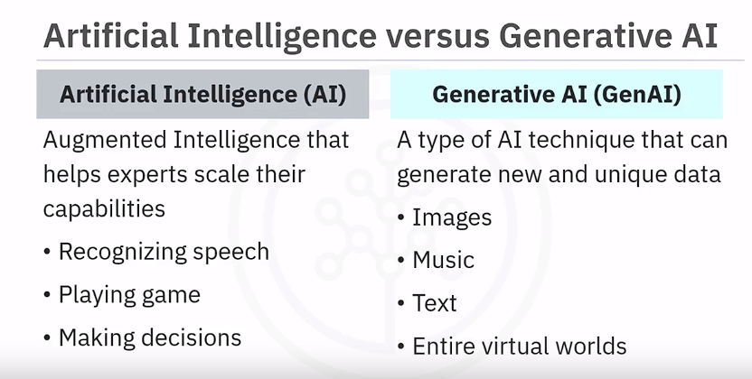

* **Generative AI** is described as an advanced AI technique capable of creating novel and unique data, spanning images, music, text, and even entire virtual worlds.
* Unlike traditional AI models relying on predefined rules, Generative AI uses deep learning techniques and vast datasets to generate entirely new data with wide-ranging applications.
* It **employs Large Language Models (LLM), a** form of artificial intelligence rooted in deep learning, to process and generate natural language, enhancing capabilities in language processing and generation.
* Generative AI's significance lies in its ability to foster creativity and innovation, save time and costs, offer personalization, scalability, robustness, and explore new possibilities in AI systems development.

**Use Cases across Diverse Industries:**

* **Healthcare and Precision Medicine:** Assists in identifying genetic mutations, provide personalized treatments options producing medical images, simulating surgeries, and predicting drug properties, aiding in tailored treatments and procedures.
* **Agriculture:** Optimizes crop yields, develops robust plant varieties resistant to environmental stressors, pests, and diseases.
* **Biotechnology:** Supports drug development by identifying potential drug targets, simulating drug interactions, and forecasting efficacy.
* **Forensics:** Aids in solving crimes through DNA analysis and suspect identification.
* **Environmental Conservation:** Assists in protecting endangered species by analyzing genetic data and suggesting conservation strategies.
* **Creative Fields:** Generates digital art, music, video content, and soundtracks for marketing, films, and games.
* **Gaming:** Creates adaptive game worlds with new levels, characters, and objects based on player behavior.
* **Fashion:** Designs virtual try-on experiences and offers personalized fashion recommendations.
* **Robotics:** Designs adaptable robot movements for complex tasks in changing environments.
* **Education:** Creates customized learning materials and interactive environments catering to different learning styles.
* **Data Augmentation:** Produces new training data for machine learning models, enhancing accuracy and performance.

**Key Takeaways:**

* Generative AI excels in creativity, cost-saving, personalization, scalability, robustness, and exploring new possibilities compared to traditional AI models.
* Its potential spans various industries, improving lives by generating novel data and experiences, akin to human intelligence's adaptability and flexibility.

This comprehensive overview details Generative AI's scope, impact, and applications across industries, emphasizing its potential to transform numerous fields and enhance AI capabilities in creating new and diverse data and experiences.

**1. Global Impact of AI:**

* **Economic Transformation:** Predicted to contribute $16 trillion to the global GDP by 2030 according to a PWC study.
* **Cross-Industry Impact:** Not confined to the IT sector, AI influences various industries and aspects of daily life.

**2. Diverse Perspectives on AI:**

* **Videogame Designers:** AI involves coding for bots' behavior and environmental reactions in games.
* **Screenwriters:** It creates characters with human-like traits mixed with computer features.
* **Data Scientists:** AI serves as a tool for exploring and categorizing data for specific goals.

**3. AI's Practical Applications:**

* **Natural Language Processing (NLP):** Enables chatbots in healthcare, education, and customer service to perform tasks like basic diagnoses, tutoring, and query resolution.
* **Speech-to-Text and Synthesis:** Enhances transcription, improves customer experiences, and assists individuals with speech disorders.

**4. Computer Vision Applications:**

* **Object Detection:** AI surpasses human capabilities, facilitating autonomous vehicle navigation and obstacle avoidance.
* **Facial Recognition:** Authentication, user tagging, and law enforcement applications.
* **Healthcare:** Automates tasks like detecting cancerous moles or identifying symptoms in medical scans.

**5. Everyday Impact of AI:**

* **Daily Integration:** Seen in Netflix suggestions, navigation apps, email filters, reminders, financial monitoring, fraud detection, and healthcare advancements.
* **Healthcare Advances:** Aid in accurate diagnoses, medical imaging analysis, and operational cost reduction.

**6. AI's Potential and Ethical Considerations:**

* **Potential Impact:** Access to vast information, human emulation, impactful recommendations, privacy invasion through data correlation.
* **Ethical Concerns:** Raises significant ethical considerations regarding privacy invasion and responsible AI deployment.

This expansion aims to provide a more detailed insight into the multifaceted nature of AI, its widespread influence across industries and daily life, and the ethical considerations surrounding its adoption and deployment.

Top of Form

**1. Robotics and Automation:**

* AI aids in improving robots' environmental perception and planning abilities, particularly in unpredictable and changing environments.

**2. AI's Pervasive Influence in Everyday Life:**

* A quote from Kevin Kelly emphasizes the ubiquitous presence of AI in virtually all aspects of human endeavors, enhancing devices and machines by making them smarter.

**3. Specific Applications of AI:**

* **Self-Driving Vehicles:** AI is crucial for vision systems, navigational intelligence, and planning/control aspects.
* **Collaborative Robotics (Cobots):** Focuses on robots designed to interact with humans, necessitating understanding human behavior and intelligence.
* **Other Applications:** Encompasses diverse areas like drug discovery, cancer treatment, and a wide array of exciting applications.

**4. AI in Healthcare:**

* AI's primary usage involves processing large datasets in real-time, making sense of the data, and creating larger-scale impacts in healthcare beyond isolated devices.

**5. Unconscious Use of AI:**

* People often unknowingly utilize AI in everyday activities like search queries, GPS navigation, and voice recognition systems.

**6. Focus on Computer Vision:**

* Computer vision, a segment of AI, assists in automating complex tasks such as identifying objects in X-ray scans or aiding security personnel in identifying potential threats.

**7. AI in Technology:**

* AI is integrated into various technologies, influencing actions like email checking through spam filtering, smart email composition, and assistance in writing emails.

**8. Impactful Sectors:**

* Highlighting AI's potential impact in crucial sectors like healthcare and education, emphasizing its role in transforming these fields.

The narrative underscores the wide-reaching influence of AI, spanning from robotics, healthcare, and collaborative robotics to daily technological applications, illustrating how AI has become an integral part of modern life and business operations.

Top of Form

let's delve into specific examples of AI applications highlighted in the provided text:

**1. Collaborative Robotics in Manufacturing and Warehousing:**

* Collaborative robots (cobots) are utilized in manufacturing, warehousing, and logistics to perform tasks that are dull or dangerous for humans.
* Examples include lifting heavy containers, assisting in shelf stocking, with potential future applications envisioned for household chores.

**2. AI in Oil and Gas Exploration:**

* In the oil and gas industry, AI, particularly computer vision, assists in classifying rock samples to identify optimal drilling locations, augmenting geologists' capabilities.

**3. Medical Knowledge Aggregation through Machine Learning:**

* Machine learning technology aggregates medical knowledge from various sources, allowing doctors globally to access and share information about rare conditions for improved diagnosis and treatment.

**4. Transformative Health Devices with AI Integration:**

* Example: Echo Devices, a company transforming stethoscopes into digital devices.
* The device captures analog sounds, converts them into digital signals, and transmits them to smartphones.
* Machine learning algorithms analyze this data, providing assistance to physicians in diagnosing heart conditions, integrating insights from previous human cardiologists' learnings.

These examples showcase AI's integration into diverse sectors, from robotics and oil exploration to healthcare devices. They highlight how AI enhances existing tools and processes, augments human capabilities, and facilitates more efficient and effective outcomes in various industries.

various applications of Generative AI highlighted in the provided text:

**1. Generative Pre-trained Transformers (GPT):**

* **Applications:** GPT models like GPT-3.5 and GPT-4 find use in:
  + **Chatbots:** Powers conversational AI, such as ChatGPT, assisting in information, tasks, creative writing, etc.
  + **Automated Journalism:** Generating news articles and content.
  + **Creative Writing:** Capable of generating human-like text across various subjects.

**2. Bard by Google:**

* **Functionality:** An AI-powered writing assistant leveraging LaMDA for generating high-quality written content for emails, social media, etc.
* **Customization:** Adapts to user preferences regarding style and tone.

**3. Watsonx by IBM:**

* **Platform Overview:** Consists of Watsonx.ai, Watsonx.data, and Watsonx.governance:
  + **Model Development:** Assists in building and deploying AI models.
  + **Scalable Analytics:** For handling data at scale.
  + **Responsible AI Workflows:** Manages AI applications and ensures ethical use.

**4. DeepDream:**

* **Application:** Generates surreal and psychedelic images from real-life images, used in art and entertainment for visually striking results.

**5. StyleGAN:**

* **Functionality:** Creates high-quality images of non-existent faces, employed in:
  + **Video Game Avatars:** Producing realistic characters.
  + **Medical Research:** Simulating human faces for research purposes.

**6. AlphaFold:**

* **Application:** Predicts protein structures, offering potential advancements in drug discovery for more effective treatments.

**7. Magenta by Google:**

* **Project Aim:** Uses generative AI for creating music and art, producing intriguing results like AI-human piano duets.

**8. PaLM 2 by Google AI:**

* **Improved Language Model:** Trained on a larger dataset, excelling in:
  + **Understanding Nuances:** Generating coherent text and code.
  + **Translation and QA:** Enhancing human-computer interactions.

**9. GitHub Copilot:**

* **AI Coding Assistant:** Developed by OpenAI and GitHub to assist developers by:
  + **Analyzing Code:** Generating suggestions, auto-completing snippets, suggesting functions based on context.

**Ethical Considerations:**

* **Concerns:** Highlighted ethical issues include potential misuse of AI-generated content and implications for intellectual property and copyright laws.

The applications cover a wide spectrum from language generation and assistance to image creation, protein structure prediction, music/art generation, and code assistance. Each application showcases the versatility and potential impact of Generative AI in various fields while underlining the ethical considerations involved in its use.

1. **Artificial Intelligence (AI)**:
   * Definition: Branch of computer science simulating intelligent behavior.
   * Demonstrates behaviors associated with human intelligence: planning, learning, reasoning, problem-solving, knowledge representation, perception, motion, manipulation, social intelligence, and creativity.
2. **Machine Learning (ML)**:
   * Subset of AI using algorithms to analyze data and make intelligent decisions without explicit programming.
   * Trained with large datasets, learning from examples rather than following rule-based algorithms.
   * Enables machines to solve problems and make predictions using provided data.
3. **Deep Learning**:
   * Specialized subset of ML using layered neural networks to simulate human decision-making.
   * Labels, categorizes information, identifies patterns, and allows continuous learning to improve accuracy.
4. **Artificial Neural Networks (ANN)**:
   * Inspired by biological neural networks but operate differently.
   * Collection of computing units (neurons) that learn from incoming data to make decisions over time.
   * Often layered deep, becoming more efficient with larger datasets.
5. **Data Science**:
   * Process for extracting knowledge and insights from large volumes of **disparate data**.
   * Involves mathematics, statistical analysis, data visualization, machine learning, etc.
   * Allows understanding, pattern recognition, and decision-making from big data.
   * It could use ml algorithms for deep learning models
6. **Differentiation between AI and Data Science**:
   * Data Science extracts knowledge from large volumes of data using various techniques including AI.
   * AI encompasses everything allowing computers to solve problems and make intelligent decisions.
   * Data Science is a broader term covering the entire data processing methodology.
7. **Intersection and Relationship**:
   * Some intersection between AI and Data Science but one isn't a subset of the other.
   * Both may involve the use of big data but differ in scope and methodology.
8. **Upcoming Topics**:
   * Further detailed discussions on machine learning, deep learning, and neural networks in upcoming lessons.

These points clarify the distinctions between AI, machine learning, deep learning, neural networks, and data science while highlighting their relationships and areas of overlap.

1. **Machine Learning (ML) in Contrast to Traditional Algorithms**:
   * ML analyzes data and learns patterns to make predictions without explicitly programmed rules.
   * Contrasted with traditional algorithms that use predefined rules to generate outcomes.
   * ML models are built based on data and answers, creating rules to determine predictions.
2. **Application of Machine Learning to Heart Failure Prediction**:
   * ML can be utilized to predict heart failure based on input data like beats per minute, body mass index, age, sex, etc.
   * In traditional programming, an algorithm (if-then-else) is crafted based on data and rules to predict outcomes.
   * In ML, models are created from the data and answers, determining the logic/rules for predictions rather than the programmers defining the rules explicitly.
3. **Machine Learning Techniques**:
   * **Supervised Learning**:
     + Trains algorithms on labeled data (e.g., pictures labeled as "bird" or "cat") to predict labels for new data.
     + The more labeled samples, the more accurate the model becomes in classifying new data.
   * **Unsupervised Learning**:
     + Ingests unlabeled data to find patterns without predefined labels.
     + Useful for clustering data based on similarity.
   * **Reinforcement Learning**:
     + Involves teaching algorithms to achieve goals through reward/punishment mechanisms.
     + Algorithms learn by trying different actions and optimizing rewards within defined constraints.
4. **Supervised vs. Unsupervised vs. Reinforcement Learning**:
   * Supervised learning relies on labeled data for training, while unsupervised learning discovers patterns without labels.
   * Reinforcement learning involves learning based on rewards and punishments in achieving goals.
5. **Use Cases**:
   * ML models can be applied in various scenarios:
     + Image classification (e.g., labeling pictures of birds or cats)
     + Network traffic analysis for detecting anomalies or malicious behavior
     + Teaching machines to play games like chess or navigate obstacle courses
6. **Machine Learning Models**:
   * ML models find patterns in data without explicitly programming these patterns.
   * These models evolve based on the data provided and can be continuously trained to improve predictions or behaviors.

These points highlight how machine learning differs from traditional algorithms, its various techniques (supervised, unsupervised, reinforcement learning), and their respective applications in different domains.

types of data subsets used, and how the performance of these models is evaluated. Let's break it down into key points:

1. **Categories of Machine Learning**:
   * **Supervised Learning**: Uses labeled data to build classification or regression models.
   * **Unsupervised Learning**: Involves discovering patterns from unlabeled data through methods like clustering.
   * **Reinforcement Learning**: Utilizes a reward-based system to guide learning and decision-making.
2. **Supervised Learning Categories**:
   * **Regression**: Models continuous relationships between features and outcomes.
   * **Classification**: Identifies discrete classes or categories based on input features.
   * **Neural Networks**: Structural models mimicking the human brain for learning and decision-making.
3. **Regression vs. Classification**:
   * **Regression** estimates continuous values, while **Classification** categorizes data into discrete classes.
4. **Types of Classification Models**:
   * Decision trees, support vector machines, logistic regression, and random forests are examples.
   * Features extracted from data (e.g., beats per minute, age) aid in classification.
5. **Training Process**:
   * Involves using labeled data to train models by showing the algorithm real-life data labeled as True or False repeatedly.
   * The algorithm adjusts internal parameters to learn to predict accurately based on training data.
6. **Data Subsets**:
   * **Training set**: Used to train the algorithm.
   * **Validation set**: Helps fine-tune model parameters and validate results.
   * **Test set**: Unseen data used to evaluate model performance.
7. **Model Evaluation**:
   * Metrics like accuracy, precision, and recall assess the model's performance.

This breakdown provides insights into how different types of Machine Learning approaches work, the role of training data, and the evaluation process used to measure the effectiveness of the models developed.

Deep Learning as a specialized subset of Machine Learning, explaining its fundamental aspects, working mechanism, and applications:

1. **Deep Learning as a Subset of Machine Learning**:
   * Specialized subset using layered algorithms to create Neural Networks.
   * Enables continuous learning, particularly from unstructured data like images, videos, and audio.
2. **Functionality of Deep Learning**:
   * Facilitates natural language understanding in AI systems, aiding in context comprehension and intent recognition.
   * Utilizes multiple layers of processing units to process data, hence the term "deep" learning.
3. **Developing Deep Learning Algorithms**:
   * Engineers configure the number of layers and connections between layers.
   * Training involves providing annotated examples, like images with corresponding labels, to detect patterns and adjust network weights.
4. **Advantages of Deep Learning**:
   * Overcomes efficiency and performance limitations of older learning algorithms, improving with larger datasets.
   * Efficiently handles various tasks: image captioning, voice recognition, facial recognition, medical imaging, language translation, and driverless cars.

This passage offers insights into how Deep Learning operates, its unique capabilities in processing unstructured data, and its wide-ranging applications across diverse fields.

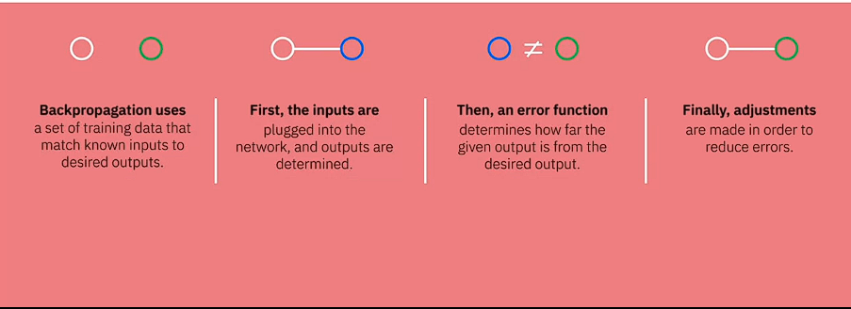

1. **Artificial Neural Networks (ANN)**:
   * Modeled on human brain processing with computing units called neurons.
   * Learn and make decisions by processing incoming data over time.
2. **Learning in Neural Networks**:
   * Utilizes backpropagation: trains with known inputs and desired outputs, adjusting to minimize errors.
   * Composed of layers: input, hidden (simulate brain activity), and output layers.
3. **Types of Neural Networks**:
   * **Perceptrons**: Simplest single-layer networks forwarding inputs to outputs via weighted connections.
   * **Convolutional Neural Networks (CNNs)**: Inspired by the visual cortex, adept at image processing and pattern recognition.
   * **Recurrent Neural Networks (RNNs)**: Process elements in sequences, considering dependencies between inputs (useful for context-based understanding).
4. **CNNs**:
   * Use convolutions to detect and construct complex features from simple structures in images.
   * Operate through layers conducting convolutions on previous layer outputs.
5. **RNNs**:
   * RNNs consider the context or sequence dependencies between inputs.
   * Enable the use of information from long sequences by representing observations at different time points in each layer.
6. **Activation Functions and Structure**:
   * Activation functions determine node responses to inputs, crucial for network success.
   * Layers consist of inputs, hidden layers applying functions to inputs, and outputs.

This passage provides detailed insights into the workings of various types of neural networks, their architectures, learning processes, and applications in diverse domains like image processing, natural language understanding, and sequential data analysis.

Top of Form

This excerpt is quite extensive and covers various aspects of AI, discussing its current hot topics and applications in different domains. Let's break it down section by section:

1. **Trustworthy AI as a Hot Topic**:
   * Dynamic nature of AI topics; continuously evolving.
   * Importance of addressing AI's potential for both good and harm.
   * IBM's five pillars for responsible AI: **explainability, transparency, robustness, privacy, and fairness.**
   * AI ethics is not a “one-and-done” activity- ethics must be considered throughout the entire lifecycle.
2. **Facial Recognition Technologies**:
   * Three categories: facial detection (identifying a face without unique identification), facial authentication (one-on-one comparison for authentication), facial matching (comparison with a database).
   * Various examples of facial recognition applications: helpful uses (airport security, unlocking devices) and concerns (privacy violations, harmful consequences).
3. **AI in Hiring and Workforce Progression**:
   * Use of AI in screening job applications, ranking candidates, and decision-making in hiring processes.
   * Caution against biases in AI-driven hiring, especially across sensitive attributes like age or ethnicity.
4. **AI in Marketing on Social Media**:
   * AI's role in transforming brand-audience interactions on social platforms.
   * AI-driven capabilities in ad creation, sentiment analysis, and audience targeting.
   * Ethical concerns regarding data collection, misinformation, and conspiracy theories arising from AI-driven marketing.
5. **Ethical Considerations and Principles in AI Usage**:
   * Emphasizes the need for enterprises to adhere to principles of transparency, explainability, trust, and privacy in AI usage.
6. **AI in Healthcare**:
   * Applications of AI in healthcare segments such as healthcare providers, payers, and life sciences.
   * Use cases like disease prediction, equitable care, conversational AI, and improving patient experience.
   * Focus on unlocking insights, improving patient experience, and ensuring trustworthiness in AI applications.

This comprehensive breakdown discusses the current landscape of AI, its applications, ethical considerations, and challenges across various sectors, highlighting both the benefits and potential risks associated with AI technology.

3 / 3

1. **Introduction to AI Ethics**:
   * Definition of AI ethics and its significance.
   * 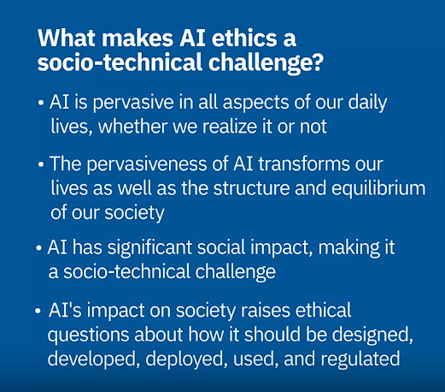
   * Illustration of AI's pervasive presence in daily life, influencing various activities, from online transactions to driving with AI-based navigation.
   * Emphasis on AI's social impact, raising ethical concerns regarding its design, development, deployment, and regulation.
2. **Socio-Technical Dimensions of AI**:
   * Involvement of diverse stakeholders (not limited to technical experts) in understanding AI's impact.
   * Importance of inclusiveness in AI development to avoid creating technology that benefits only a select few.

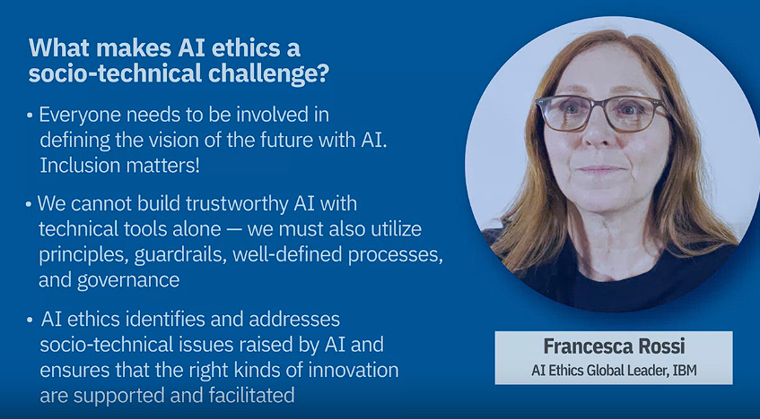

1. **Role of Guidelines and Governance**:
   * The need for guidelines, principles, processes, and effective governance to direct the ethical use of AI.
   * Comparison of guidelines to traffic rules, emphasizing that appropriate rules actually expedite progress rather than hinder it.
2. **Ethics in AI Development Lifecycle**:
   * IBM's CEO's quote emphasizing trust as a foundation for operation.
   * Incorporation of ethics throughout the design and development lifecycle of AI.
   * The requirement for an ethical, multidisciplinary approach involving principles, values, laws, and societal benefits.
3. **IBM's Principles and Pillars of Trust and Transparency**:
   * Introduction to IBM's principles: augmentation, ownership of data, and transparency.
   * Overview of the five pillars: transparency, explainability, fairness, robustness, and privacy.
   * The insufficiency of principles and pillars alone; the need for tools and practitioners to continuously monitor and mitigate risks.
4. **Putting AI Ethics into Action**:
   * Building understanding and awareness among teams about AI ethics, ensuring a user-centric approach.
   * Implementing a governance structure to scale AI ethics across the organization.
   * Operationalizing AI ethics by ensuring clarity and understanding among developers, data scientists, and vendors globally.

The breakdown covers the significance of AI ethics, the involvement of diverse stakeholders, the necessity of guidelines and governance, IBM's ethical principles and pillars, and steps to implement AI ethics within organizations, highlighting the need for understanding, governance structures, and operationalization.

1. **Introduction to AI Ethics**:
   * Explanation of the importance of ethics in decision-making, especially as AI increasingly impacts various aspects of society.
   * Definition of AI ethics as a multidisciplinary field aimed at maximizing AI's positive impacts while minimizing risks and adverse effects.
   * Identification of key areas explored within AI ethics: data responsibility, privacy, inclusion, moral agency, value alignment, accountability, and technology misuse.
2. **Five Pillars of AI Ethics**:
3. 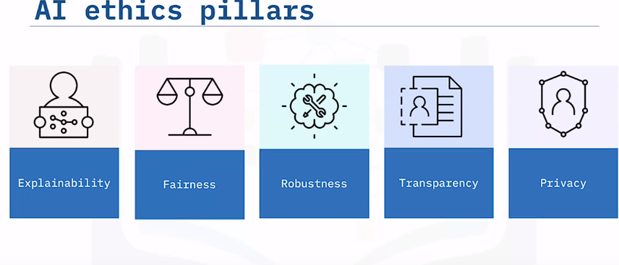
   * **Explainability**: AI should be capable of demonstrating how and why it arrives at specific outcomes or recommendations, akin to "showing its work".
   * **Fairness**: AI should treat individuals or groups equitably, counterbalancing human biases and actively mitigating(**Making less effectful)** bias inherent in AI systems.
   * **Robustness**: AI should effectively handle exceptional conditions, such as abnormal input or adversarial attacks, ensuring stability and resilience against interference.
   * **Transparency**: Human users should have access to information about how the AI system was designed and developed, including data used, data handling processes, and access protocols.
   * **Privacy**: AI systems should prioritize and safeguard human privacy and data rights, collecting only essential data and never repurposing collected data without user consent.
4. **Summary**:
   * Reiteration of how these five pillars — explainability, fairness, robustness, transparency, and privacy — collectively aid in designing, developing, deploying, and using AI more ethically. They ensure AI aligns with human ethics and expectations while addressing potential risks and issues.
5. **Introduction to Bias in AI**:
   * Bias in AI pertains to unwanted behaviors where AI systems used in significant decision-making tasks, like lending, hiring, or criminal justice, systematically disadvantage certain groups or individuals.
   * Examples include healthcare algorithms favoring white people over black people for preventative healthcare or biased hiring algorithms favoring men over equally qualified women.
6. **Sources of Bias**:
   * AI systems are trained on historical human decisions, potentially reflecting biases from past decision-makers.
   * Data sampling might lead to overrepresentation or underrepresentation of certain groups.
   * Data processing or feature engineering in data science projects can introduce biases unintentionally.
   * Even defining the problem itself can lead to biases, like predicting criminality based on arrest records, which don't equate to guilt.
7. **Addressing Bias**:
   * Recognizing biases is crucial. Diverse teams with varied experiences can identify and address these biases effectively.
   * Seeking data sets that counteract biases can help mitigate inherent biases in AI training data.
   * Implementing technical approaches like introducing constraints or statistical measures in machine learning models can help mitigate biases. Several algorithms designed for this purpose are available in open-source AI fairness toolkits.
8. **IBM's Approach to Ethical AI**:
   * IBM focuses on conscious inclusion through Good Tech via its AI Ethics Board, comprising diverse IBM members committed to eliminating bias and setting standards.
   * IBM leverages AI and data skills to develop assets addressing bias, promote inclusive language in tech, and ensure rigorous testing to minimize potential biases.
   * In Diversity & Inclusion (D&I) and HR, AI and data insights inform decision support, affecting pay, retention, hiring, promotion decisions, and compliance requirements globally.
9. **AI Regulations Overview**:
   * Regulations in the context of AI refer to government-enforced rules that dictate how AI can be developed, deployed, and used within legal and ethical boundaries.
10. **Evolving Regulatory Landscape**:
    * The regulatory environment surrounding AI is rapidly changing, emphasizing the need for a deep understanding of these regulations for those involved in AI development and deployment.
11. **IBM's Position on AI Regulation**:
    * IBM advocates for what they term "precision regulation" of AI, aiming for regulations that are risk-based, context-specific, and assign responsibilities to the party closest to the risk at different stages of the AI lifecycle.
12. **Precision Regulation Framework**:
    * IBM's proposed framework includes five key policy imperatives for organizations dealing with AI systems:
      + Designate an AI ethics official responsible for ensuring compliance with trustworthy AI.
      + Tailor rules according to different risks, focusing on regulating AI within specific contexts rather than regulating the technology itself.
      + Emphasize transparency in AI systems, making them explainable rather than operating as black box decisions.
      + Implement testing procedures to detect and mitigate biases in AI systems.

This framework aims to encourage responsible and ethical AI practices by integrating considerations for transparency, fairness, accountability, and bias mitigation into the regulatory framework surrounding AI.

Top of Form

The video addresses several key points regarding AI ethics, governance, and ESG (Environmental, Social, Governance):

1. **AI Governance**:
   * Governance in AI involves overseeing the organization's actions throughout the AI lifecycle, ensuring that AI systems operate as intended, align with stakeholder expectations, and comply with relevant regulations.
   * It aims to achieve trustworthy AI by setting requirements for accountability, responsibility, and oversight.
2. **Benefits of Governance**:
   * Trust: Aligning AI activities with organizational values builds transparent, fair, and trustworthy systems, enhancing client satisfaction and brand reputation.
   * Efficiency: Standardizing and optimizing AI activities accelerates development and time to market.
   * Compliance: Managed and monitored AI activities can be adjusted more easily to meet new industry regulations and legal requirements.
3. **Elements of Successful Governance**:
   * People: Clearly defining roles and responsibilities for individuals involved in building and managing trustworthy AI, including leaders setting policies and ensuring accountability.
   * Processes: Establishing procedures for building, managing, monitoring, and communicating about AI systems.
   * Tools: Leveraging technology for better visibility and consistency in AI system performance across the AI lifecycle.
4. **ESG (Environmental, Social, Governance)**:
   * ESG factors measure non-financial risks and opportunities at companies.
   * At IBM, the ESG strategy focuses on three pillars: environmental impact, equitable impact, and ethical impact, aiming to create a more sustainable future.
   * Governance within ESG emphasizes ethics, trust, transparency, and accountability, with AI ethics being a significant aspect of governance initiatives.
5. **AI Ethics in Governance Initiatives**:
   * IBM is committed to training 1,000 ecosystem partners in tech ethics in 2022, aiming to ensure that the benefits of AI are accessible to many and fostering a culture of trustworthy AI beyond IBM.

The goal is to align AI practices with ethical principles, ensure transparency, accountability, and sustainability, and involve a broader ecosystem in cultivating a responsible approach to AI development and deployment.

Top of Form



Bottom of Form

Top of Form

Top of Form

Top of Form